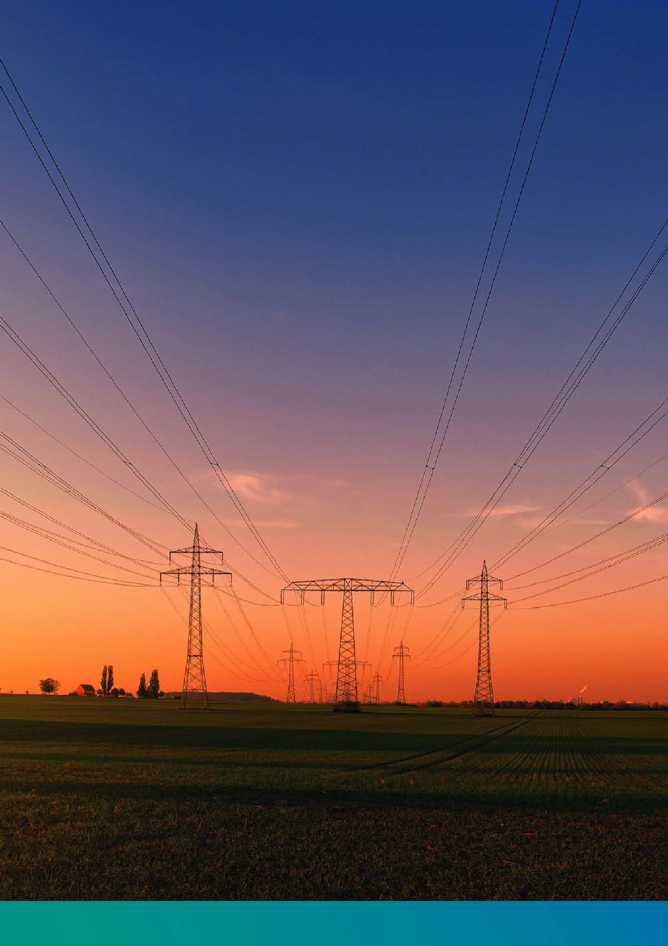

Voltage Optimisation Energy Savings Proposal

**image_placeholder**

**This year you may overspend**

**£ {{Annual spend}} On Your Electricity Bill**

{{Sitename}}

Quote Ref: {{Quote}}

[**www.emissis.co.uk**](http://www.emissis.co.uk)

image_placeholder1



## YOUR VO PROPOSAL:

1. What you require Page. 3
2. What we propose Page. 4
3. How does VO help? Page. 5
4. How we work out our savings Page. 6
5. Financial Savings Page. 7
6. Savings Guarantee Page. 8
7. Your Emissis VO Energy Purchase Page. 9
8. Terms & Conditions Page. 10
9. Emissis Monitoring & Verification Page. 11
10. Emissis Manufacturers Equipment Warranty Page. 12
11. Proposal Summary Page. 13



**WHAT YOU REQUIRE**

**About {{Sitename}}**

* {{about}}
* {{Sitename}} is committed to environmentally sustainable policies and practices within their local and global communities.

**What you want to achieve:**

* A reduction in the consumption on site, helping to reduce operating costs.
* A decrease in the CO2 emissions the site produces due to its electricity consumption, with Net Zero targets in mind.

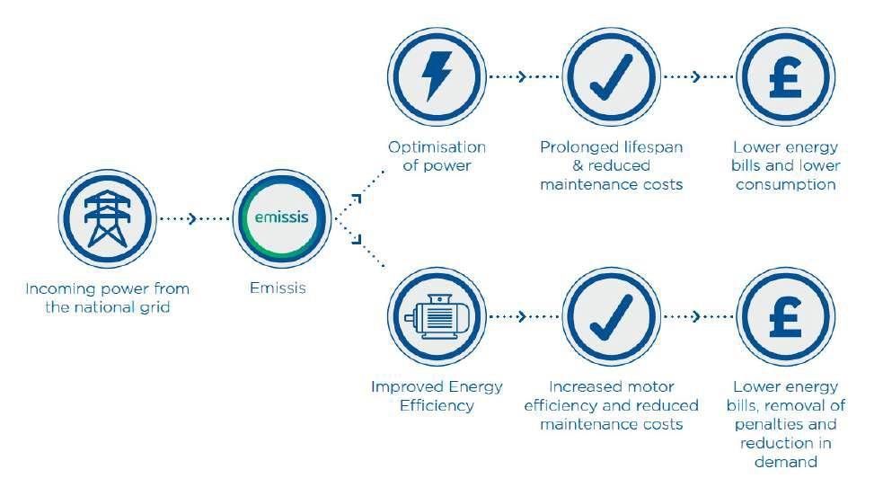

## WHAT WE PROPOSE

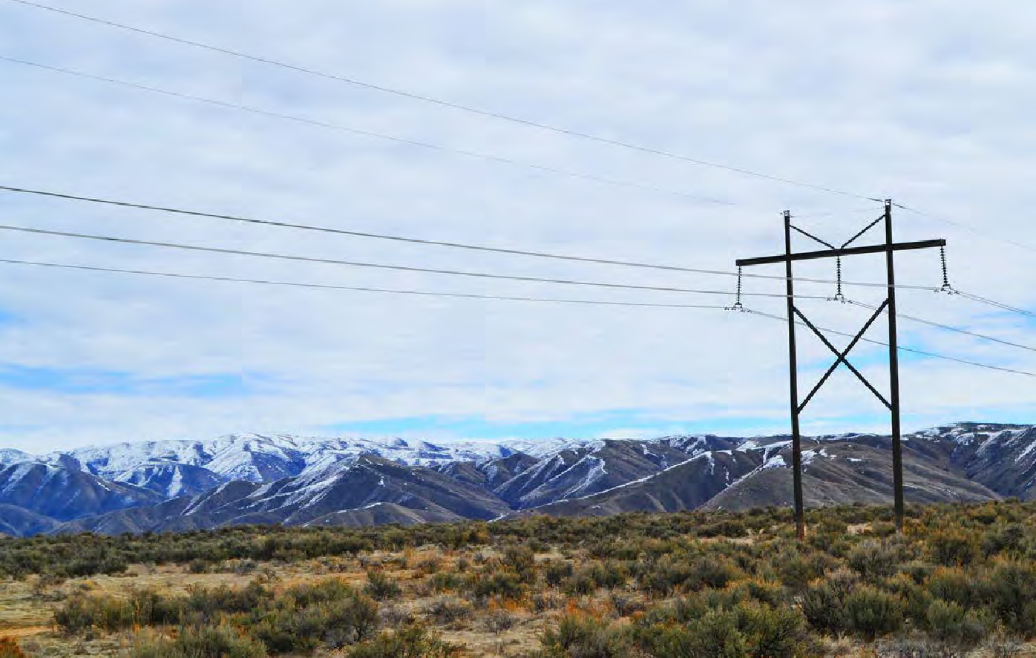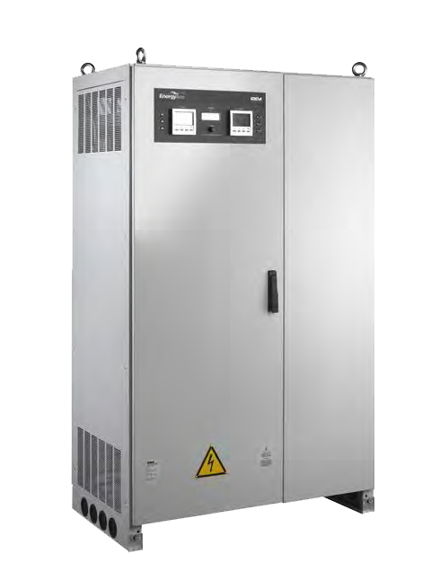

* This proposal is based on data provided to Emissis: Half Hourly Data (HHD) of site consumption and Energy Prices from a recent bill.
* From this data, we chose the Emissis Voltage Optimisation units to match the supply demand.
  + The Emissis Voltage Optimisation Units are sized with a +30% (min.) headroom on max demand to ensure that that the site is future proof.

For {{Sitename}}

We recommend:

1 x EMC - {{VO Size}}

(THREE-PHASE Emissis Voltage Optimisation System Rated {{VO Size}} Amps)

## HOW DOES VO HELP?

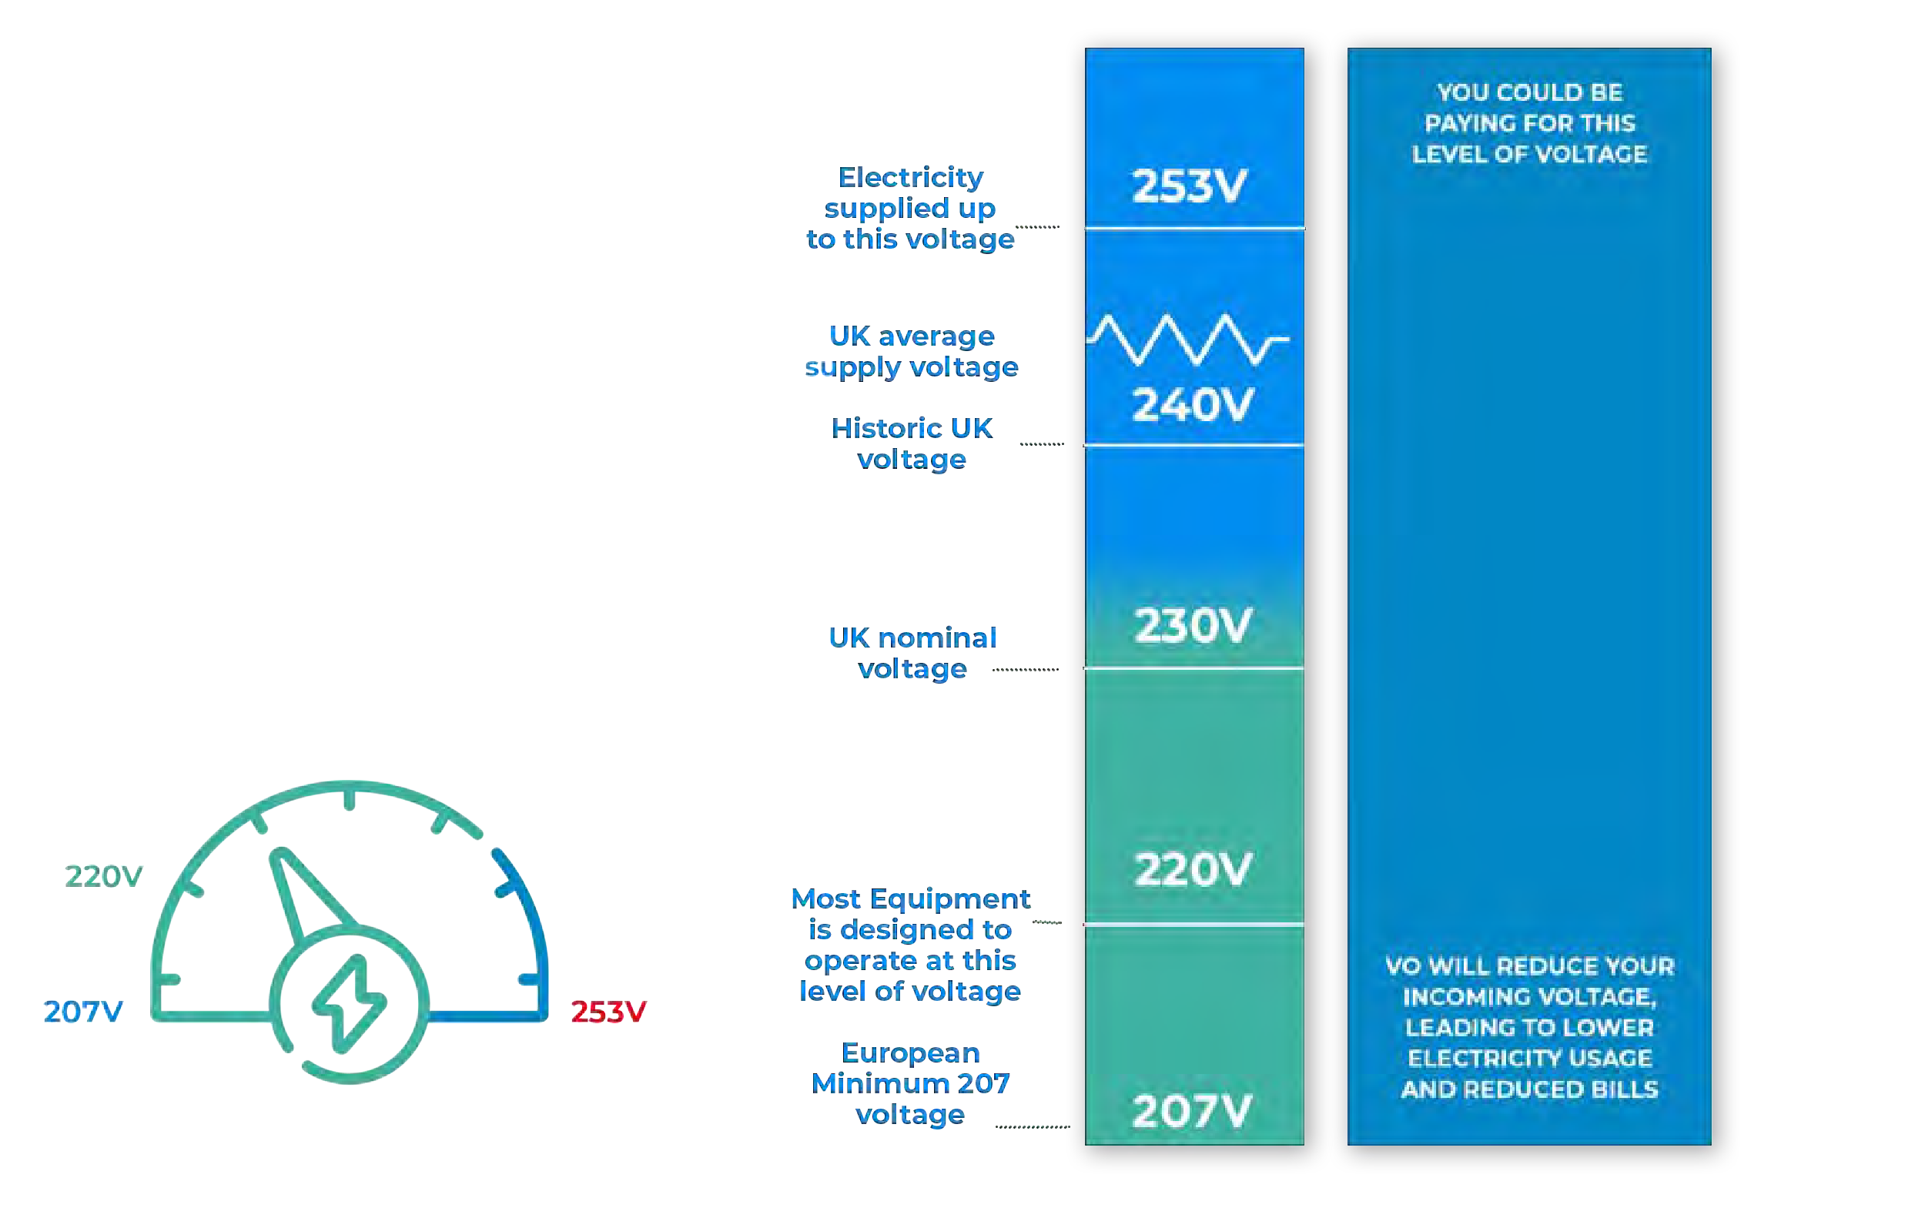

Voltage levels provided by power companies in the UK and other countries are not typically matched to the optimum level for most electrical

equipment. Voltage Optimisation is a method of reducing mains voltage to save energy, reduce costs and maximise equipment efficiency.

Using Voltage Optimisation with electrical equipment such as refrigeration or air cooling devices, 3-phase motors, high-intensity discharge

or fluorescent lighting, will reduce energy consumption and create real financial savings. Voltage Optimisation also increases the

service life of electrical equipment by running at the lower voltages that the equipment was designed to run at.

In Europe, generating companies are required to provide customers with a voltage between 207V and 253V. The average voltage across the UK is 245V, but levels can fluctuate significantly throughout the day on each site. Across Europe, the standard voltage has been historically 220V.

As a result, most electrical equipment is designed and specified to operate most effectively and efficiently at 220V. Providing equipment with

higher voltages actually reduces efficiency and leads to wasted energy.

**This year you may overspend**



**£ {{Annual spend}} On Your Electricity Bill**

## HOW WE WORK OUT OUR SAVINGS

##### Where Voltage management is concerned, there are two main categories of load:

Voltage-dependent:

A voltage-dependent load is an electrical device whose power consumption varies with the voltage being supplied to it.

Voltage independent:

A voltage-independent load is an electrical device whose power demand, within its designed operating range, is independent of supply voltage. To accurately predict the level of savings your Emissis Voltage

Management Systems will generate, it is important to accurately document the load profile as detailed below.

|  |  |  |  |
| --- | --- | --- | --- |
| **Load Profile** | **TOTAL LOAD%** | **SAVING %** | **TOTAL SAVING %** |
| Lighting with Magnetic Ballast (Old Style Lighting with T10/T8 Tube etc) | {{l%1}} % | {{sp1}} % | {{ts1}} % |
| Lighting with Electronic Control (T5/LED/Electronic Ballast/High Frequency) | {{l%2}} % | {{sp2}} % | {{ts2}} % |
| Refrigeration/Chillers/Freezers/Air Conditioning (Without Inverter) | {{l%3}} % | {{sp3}} % | {{ts3}} % |
| Refrigeration/Chillers/Freezers/Air Conditioning (With Inverter) | {{l%4}} % | {{sp4}} % | {{ts4}} % |
| Heating Ventilation and Air Conditioning (HVAC) | {{l%5}} % | {{sp5}} % | {{ts5}} % |
| Heater/Kitchen Equipment/Resistive Loads (Without Thermocouple) | {{l%6}} % | {{sp6}} % | {{ts6}} % |
| Computer/Electronic/General IT Equipment | {{l%7}} % | {{sp7}} % | {{ts7}} % |
| Motors/Machinery/Pumps etc | {{l%8}} % | {{sp8}} % | {{ts8}} % |
| Inverter Drives | {{l%9}} % | {{sp9}} % | {{ts9}} % |
| Other Non-Saving Load | {{l%10}} % | {{sp10}} % | {{ts10}} % |

**TOTAL SAVING : {{per}} %**

## FINANCIAL SAVINGS

|  |  |
| --- | --- |
| Financial kWH Savings: | £ {{£kWh}} |
| Financial kWh CCL: | £ {{CCL}} |
| Trading Tons CO2 | {{co21}} Tons |
| ROI: | {{ROI Months}} months |

graph1

|  |  |
| --- | --- |
| One Year Savings (£{{tariff}} / kWh): | £ {{Annual spend}} |
| Five Year Savings: | £ {{cost5}} |
| Ten Year Savings: | £ {{cost10}} |

graph2

## VOLTAGE OPTIMISATION GUARANTEE & WARRANTY

All our voltage equipment is supplied with a 15-year manufacturer's equipment warranty that confirms (warrants) that the equipment supplied will continue to deliver the voltage reduction guaranteed and will operate efficiently for a minimum of 15 years from the date of installation.

Our equipment is installed with an expected lifespan of 30 + years subject to a 5-year service plan. We guarantee that your Voltage Optimiser will continue to deliver the voltage reduction specified in our Energy Savings report. After a full site power survey, this finalised savings report will confirm the reduced voltage figure, your site's confirmed load profile together with the percentage of energy consumption that has been disregarded to allow for equipment that delivers little or no energy savings from voltage optimisation.

The Savings Guarantee, post-site survey, confirms the energy savings that a {{per}} % reduction in electrical consumption will deliver. Our intelligent power monitoring & verification process will support your guarantee by giving you access to the following data:

* Confirm the exact optimised voltage and energy saving in line with your site load profile & voltage dependency
* Allow you to compare your electricity bills and HHD both with and without your Voltage Optimiser

We guarantee that if your voltage equipment has not paid for itself within {{ROI Years}} years we will continue to make up the difference between achieved savings and ROI target savings until your ROI is reached.

Note: For accurate data comparisons to be made, pre and post-optimisation, consideration needs to be made for any additional equipment installed or removed. In addition, if the operating time of the electrical equipment & appliances changes due to production time increasing or decreasing this will clearly affect power consumption & savings.

Our equipment suppliers of over 20 + years and EMC have never been asked to reimburse any client. Together we have installed over 5000 optimisers and can offer case studies & referrals across every UK industrial & commercial sector that will reinforce the savings that our optimisers are delivering.



## YOUR EMISSIS VO ENERGY PURCHASE:

Items: 1 Description:

Emissis Compact Voltage Management Energy Saving System Rated 1x {{VO Size}} (Amps)

Part Number EMC CVO {{VO Size}}-3P

Benefits & Outstanding Unique Features Not Found in Standard – Static Voltage Optimisation

* Reduction in kWh Energy Consumption
* Reduction in Reactive Power Charges (penalty for inefficient users)
* Reduction in Circuits Currents & kVA (improves utility)
* Reduction in CO2 Emissions
* Fixed Voltage taps at -10v, -15v, -20v & -25v
* Allows for finer control of the voltage to ensure maximum savings
* MCCB Protection
* Small Footprint
* 3 years monitoring & verification to include monthly energy reduction & savings report
* Remote metering, programming & control
* Access to a cloud-based energy monitoring & savings portal

**GRAND TOTAL: £ {{Capital Cost}}** + VAT

**(including Installation)**

**Electrical Mechanical Cooling**



## TERMS & CONDITIONS

Sizing

The unit has been sized from the HHD supplied by the client on the assumption that HHD is a KW Demand figure.

Installation

All installations assume normal working hours with any planned shutdown for final connection to be carried out at a mutually convenient out of hours period - Installation in all cases assumes

indoor without any special conditions. All installations are subject to local isolation availability, but do not include any DNO or landlord involvement. Our prices do not include the cost of the DNO.

Trading Tons CO2 Savings & Energy Cost

Savings assume participation in the EU ETS Scheme (EU Emissions Trading System and increase in energy costs of 8% per annum).

Load Profile

The load profile for each supply contains loading % and degree of each type of load of which should all be confirmed to ensure all savings are accurate.

Delivery

Delivery costs are included within our offer to the UK mainland.

15 Years Warranty

15 Years Warranty, subject to a regular maintenance program.

Terms

Delivery: 5-8 Weeks

Prices: All Prices Subject to VAT

Payment Terms: 50% Deposit / Balance on installation

Quote Validity: 3 Months



## EMISSIS MONITORING & VERIFICATION

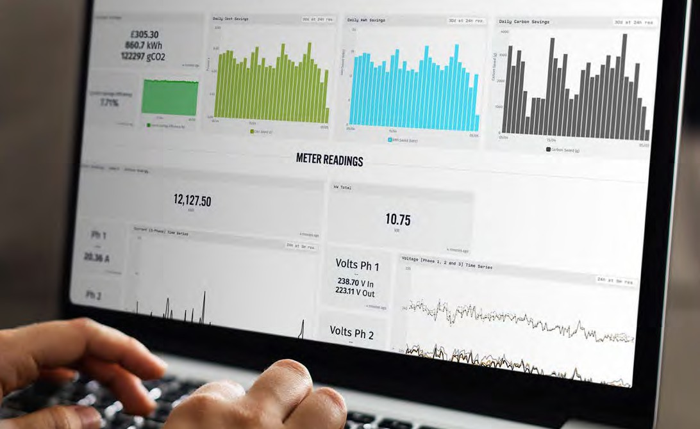

Our voltage optimisation maintenance service package is complimentary for the initial three years following purchase and consists of one annual inspection at 30 months.

In year 4 an annual service contract to include 24/7 monitoring will be offered at a cost of

£295 + VAT per year which includes a regular inspection visit after 5 years and thereafter every 30 months.

### Real-Time Monitoring:

* + - Remote monitoring via cloud-based platform.
    - Logging of consumption, energy savings, power, current, and voltage per phase.
      * Alarms remotely recorded, insights into historic performance.
      * Provides complete visibility on energy spend – find out where your money is going.
* Completely transparent with customer interface – access your data anytime, anywhere.
* Complete turnkey solution to energy reduction – Emissis takes care of the data analysis and provides the best solution for your needs. All you need to do is enjoy the savings.
  + Emissis remote service team for continuous support.
    - Remote troubleshooting



## Emissis Manufacturers Equipment Warranty

Emissis stands behind the quality and durability of our Voltage Optimisation equipment. We provide a warranty guaranteeing that our equipment will consistently deliver the promised voltage reduction and operate flawlessly for a minimum of 15 years from the installation date.

With our commitment to customer satisfaction, you can trust in the long-lasting performance and reliability of our cutting-edge technology.

We have meticulously designed and tested each component to ensure that it withstands the test of time. Choose our Voltage Optimisation equipment and enjoy the benefits of sustainable energy management for years to come.



1**5 Years Manufacturers Warranty**

**Made in the UK Finance Options Available**





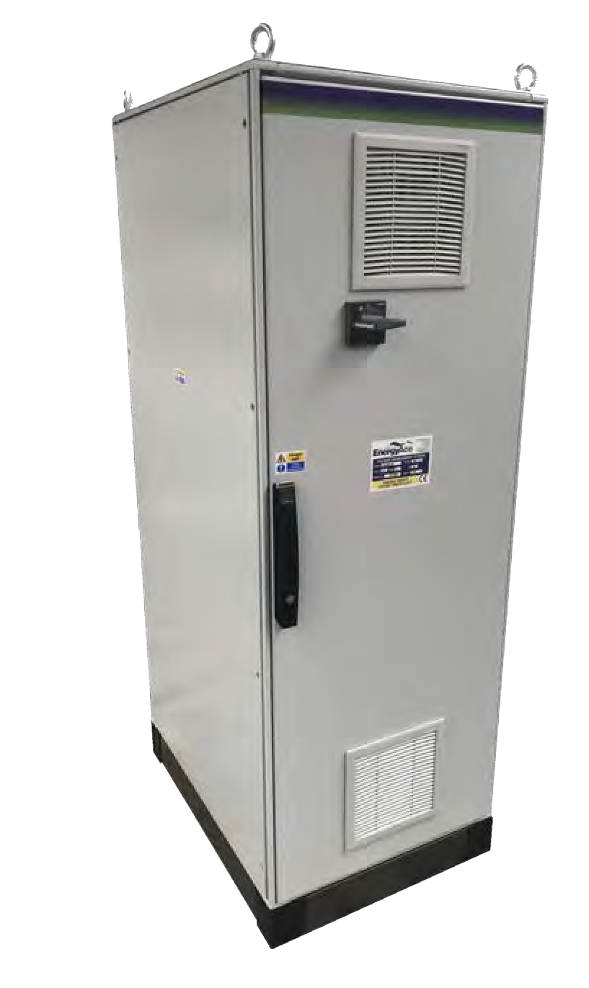

## SUMMARY

|  |  |
| --- | --- |
| Total Annual kWh savings: | {{kWh}} |
| Total Annual Financial Savings: | £ {{Annual spend}} |
| Total Capital Cost: | £ {{Capital Cost}} |
| ROI: | {{ROI Years}} years |

### A white box with a black handle Description automatically generatedContact Emissis

###### PREPARED BY:

**Paul Beck | Head of Marketing**

**Tel: +44 (0) 1642 049024**

**Email:** [**paul.beck@emissis.com**](mailto:paul.beck@emissis.com)

###### OFFICE:

**Tel: +44 (0)1642 049024**

**Email:** [**enquiries@emissis.com**](mailto:enquiries@emissis.com)

###### ADDRESS:

**401, 76 King Street M2 4NH, Manchester**